Assignment Day 1

1)

Html

<!DOCTYPE html>

<html lang="en">

<head>

    <meta charset="UTF-8">

    <meta name="viewport" content="width=device-width, initial-scale=1.0">

    <title>Document</title>

    <link rel="stylesheet" href="business development.css">

</head>

<body>

    <div class="box">

        <h2>Business <br> Development</h2>

        <p>Have an idea or inquiry for waze business development?</p>

        <button class="btn"><b> Share your ideas</b> </button>

    </div>

</body>

</html>

CSS

.box{

    background-color: rgb(3, 249, 135);

    border: none;

    width: 800px;

    height: 600px;

    padding: 50px;

    margin: 10px;

    border-radius: 20px;

}

h2{

    font-size: 50px;

    padding-top: 60px;

    font-family: system-ui, -apple-system, BlinkMacSystemFont, 'Segoe UI', Roboto, Oxygen, Ubuntu, Cantarell, 'Open Sans', 'Helvetica Neue', sans-serif;

}

p{

    font-size: 25px;

}

.btn{

    background-color: white;

    border: none;

    border-radius: 60px;

    font-size: 25px;

    padding-left: 40px;

    padding-right: 40px;

    padding-top: 10px;

    padding-bottom: 10px;

}

Out put:-

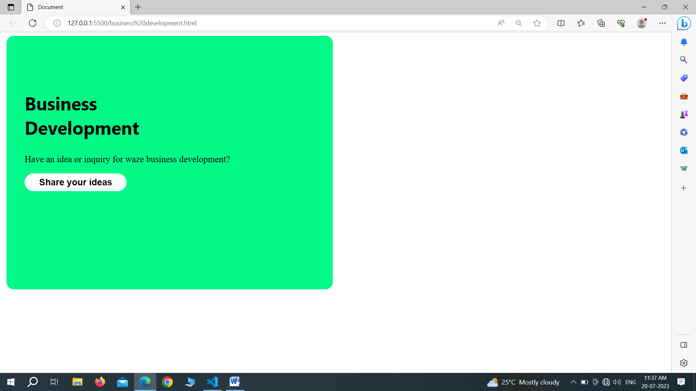

2)

Html

<!DOCTYPE html>

<html lang="en">

<head>

    <meta charset="UTF-8">

    <meta name="viewport" content="width=device-width, initial-scale=1.0">

    <title>Document</title>

    <link rel="stylesheet" href="profil.css">

</head>

<body>

    <div class="profile">

        <h2 class="h2">Your profiles</h2>

        <p>see how your different profiles appar in google services</p>

        <img src="https://source.unsplash.com/1600x1000/?burger" class="user" alt="">

        <img src="https://source.unsplash.com/1600x1000/?burger" class="users" alt="">

        <div class="link">

            <a href="">see profiles</a>

        </div>

    </div>

</body>

</html>

Css

.profile{

    width: 550px;

    margin: 80px auto;

    border: 1px solid lightgray;

    border-radius: 14px;

    padding: 10px;

    font-family: system-ui, -apple-system, BlinkMacSystemFont, 'Segoe UI', Roboto, Oxygen, Ubuntu, Cantarell, 'Open Sans', 'Helvetica Neue', sans-serif;

}

.user{

    height:100px;

    width: 100px;

    border-radius: 50%;

}

.users{

    height: 100px;

    width: 100px;

    border-radius: 50%;

}

.link a{

    font-size: 18px;

}

p{

    font-family: system-ui, -apple-system, BlinkMacSystemFont, 'Segoe UI', Roboto, Oxygen, Ubuntu, Cantarell, 'Open Sans', 'Helvetica Neue', sans-serif;

    font-size: 26px;

    padding: 20px;

}

.h2{

    font-family: system-ui, -apple-system, BlinkMacSystemFont, 'Segoe UI', Roboto, Oxygen, Ubuntu, Cantarell, 'Open Sans', 'Helvetica Neue', sans-serif;

    font-size: 32px

}

Output :

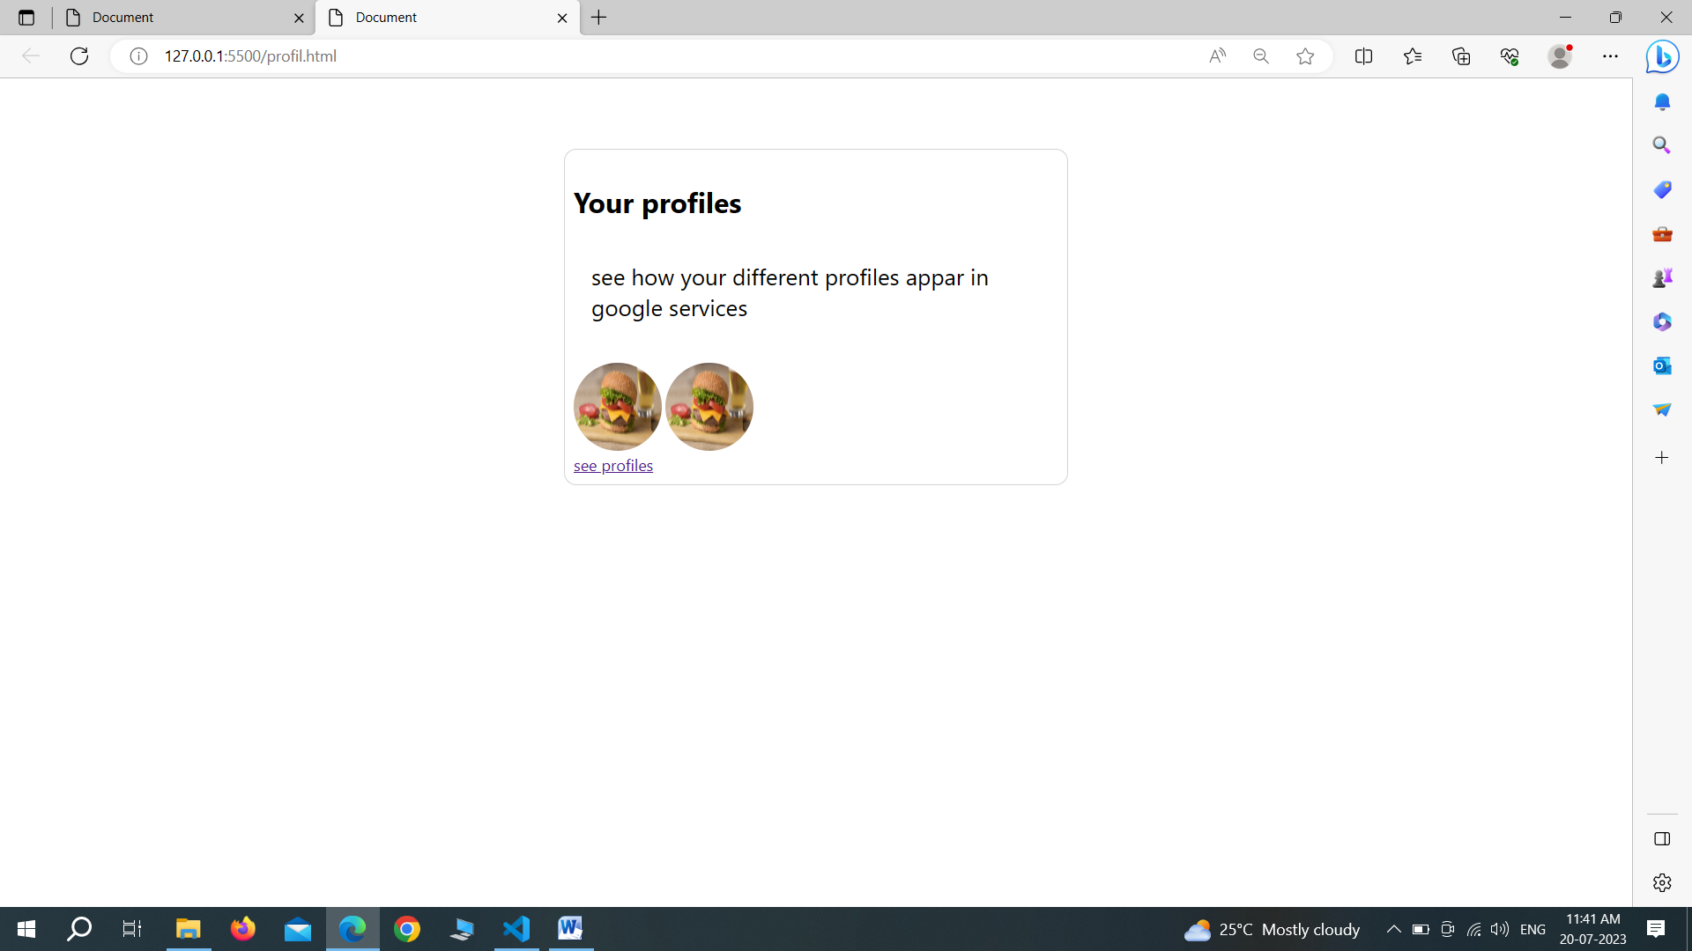

3)

Html

<!DOCTYPE html>

<html lang="en">

<head>

    <meta charset="UTF-8">

    <meta name="viewport" content="width=device-width, initial-scale=1.0">

    <title>Document</title>

    <link rel="stylesheet" href="getmorefuture.css" class="css">

</head>

<body>

    <div class="box">

        <img src="https://source.unsplash.com/1600x1000/?phone" alt="" class="img">

        <div class="text">

            <h2>Get more features in Google Photos</h2>

            <p>Lorem ipsum dolor sit amet consectetur, adipisicing elit. Numquam doloribus optio tempore </p>

            <div class="vd">

                <a href="">View details</a>

            </div>

        </div>

    </div>

</body>

</html>

Css

.box{

    border: 1px solid lightgray;

    width: 560px;

    margin: 200px 700px;

    border-radius: 15px;

    align-items: center;

    padding-bottom: 15px;

}

img{

    width: 100%;

    border-top-left-radius: 14px;

    border-top-right-radius: 14px;

}

h2{

    font-size: 36px;

}

.text{

    padding-left: 20px;

}

.text p{

    font-size: 26px;

}

.vd{

    border: 1px solid lightgray;

    width: 110px;

    padding-left: 20px;

    padding-right: 20px;

    padding-top: 08px;

    padding-bottom: 08px;

    font-family: system-ui, -apple-system, BlinkMacSystemFont, 'Segoe UI', Roboto, Oxygen, Ubuntu, Cantarell, 'Open Sans', 'Helvetica Neue', sans-serif;

}

.vd a{

    color: blue;

    font-size: 20px;

}

Output –

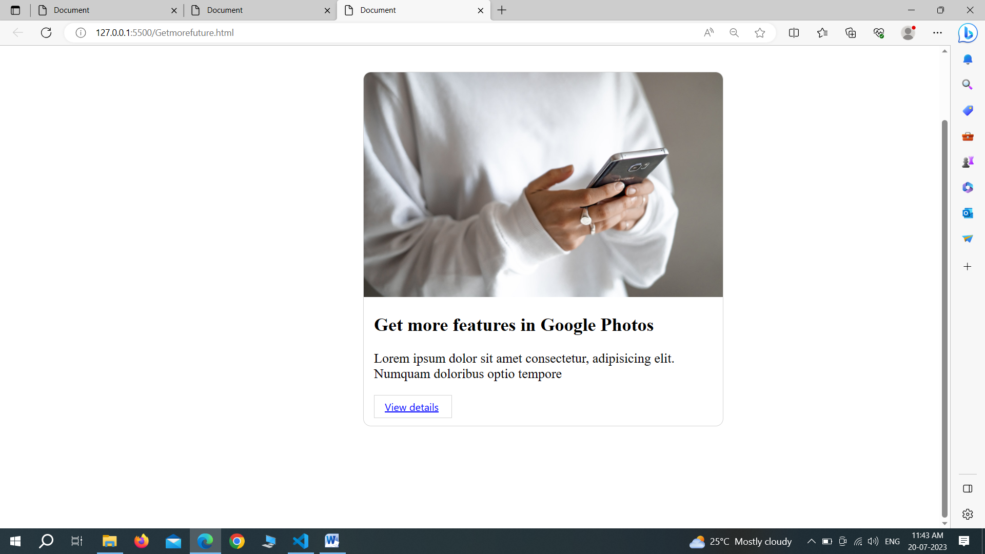

4)

Html

<!DOCTYPE html>

<html lang="en">

<head>

    <meta charset="UTF-8">

    <meta name="viewport" content="width=device-width, initial-scale=1.0">

    <title>Document</title>

    <link rel="stylesheet" href="login.css" class="css">

</head>

<body>

    <div class="box">

        <h1>flodesk</h1>

        <h4>Welcome back!</h4>

        <input type="text" placeholder="Enter youe email" class="input"><br>

        <input type="password" placeholder="Enter your password" class="input">

<br>

        <button class="btn">Log to Flodesk</button>

        <h3>Not a member?<a href="">Sign up</a></h3>

        <a href="">Forget your password?</a>

        <h5>By continuing you agree to Flodesks <a href="">term</a></h5>

        <h5>and acknowledge you've read our <a href="">privacy policy</a></h5>

    </div>

</body>

</html>

Css

.box{

    width: 380px;

    box-sizing: border-box;

    text-align: center;

    margin: 40px auto;

    font-family: system-ui, -apple-system, BlinkMacSystemFont, 'Segoe UI', Roboto, Oxygen, Ubuntu, Cantarell, 'Open Sans', 'Helvetica Neue', sans-serif;

    padding: 10px;

}

.box input{

    border: 1px solid lightgray;

    border-radius: 12px;

    font-size: 17px;

    width: 100%;

    margin-bottom: 12px;

    padding: 16px;

    box-sizing: border-box;

}

.btn{

    background-color: black;

    color: white;

    border: none;

    border-radius: 19px;

    padding: 12px 55px;

}

h1{

    font-size: 56px;

}

h3{

    font-size: 14px;

}

Output-

